**Practical No. 03**

**Aim: Working with Docker Containers and Commands: Pulling and pushing image to docker.**

Create Docker Hub account (sign up)

Login to <https://labs.play-with-docker.com/>

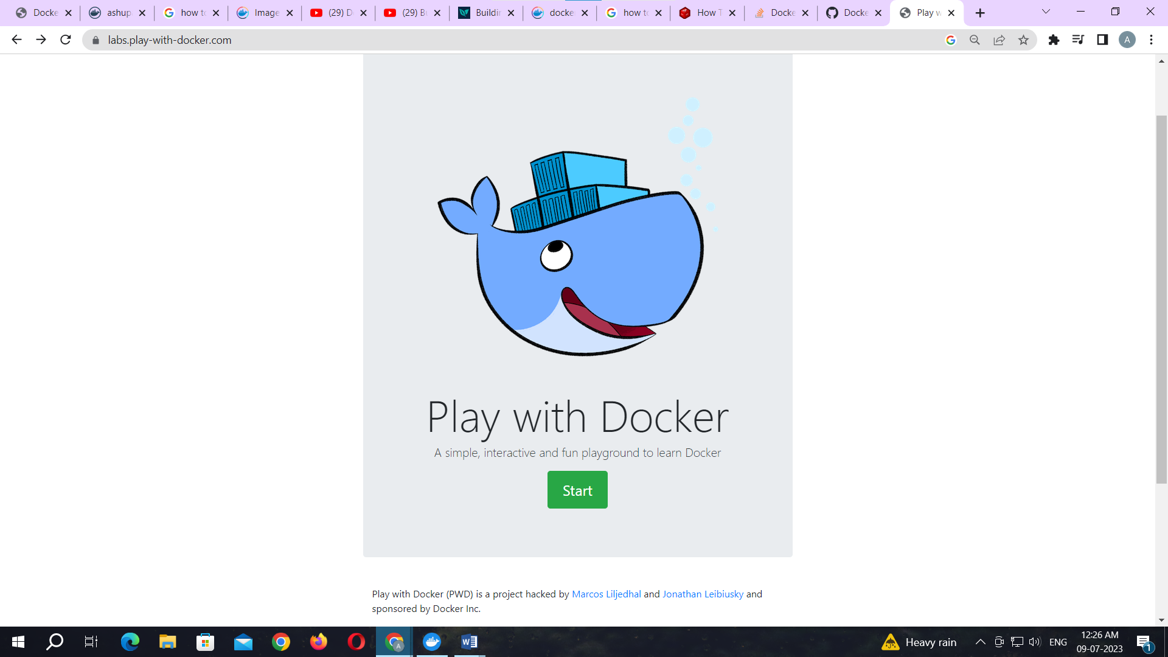

Click on start

Add new instance

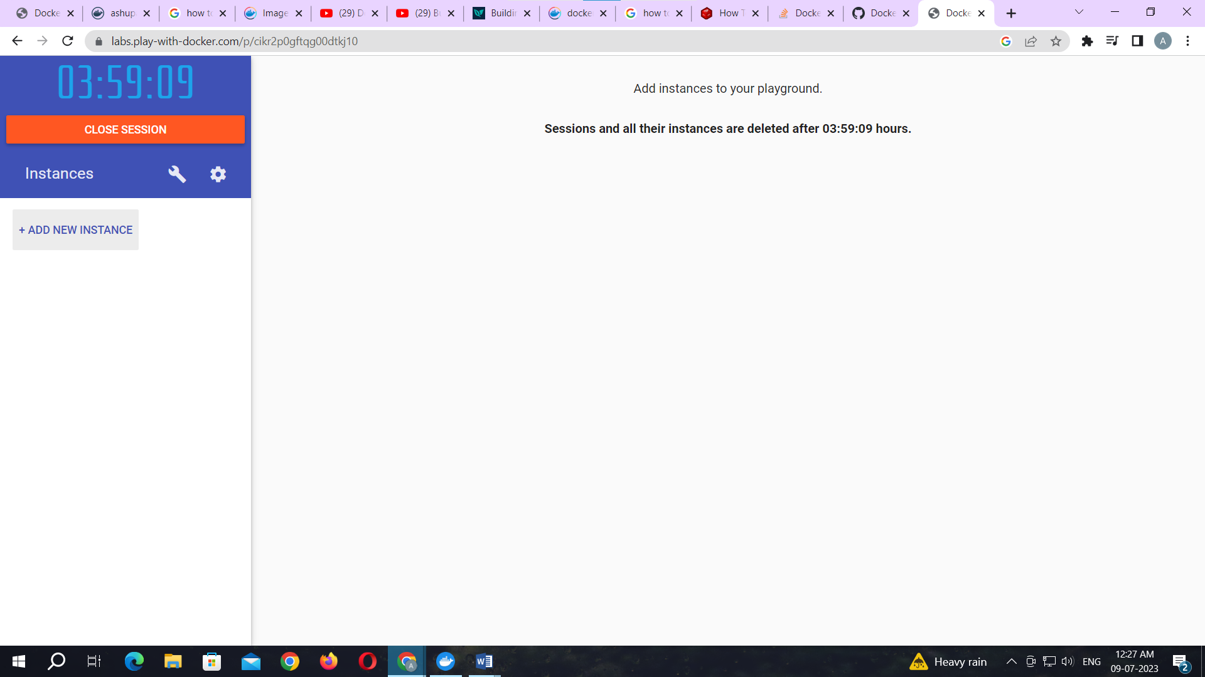

To pull and push images using docker

Command: to check docker version

docker –version

**Output:**

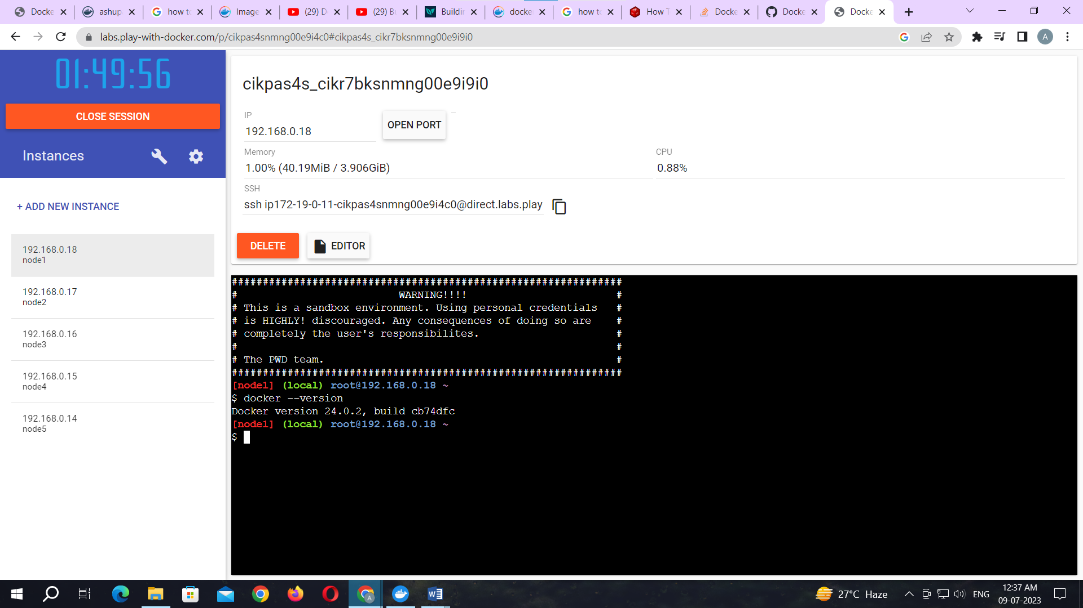

Command: to pull readymade image

docker pull rocker/verse

**Output:**

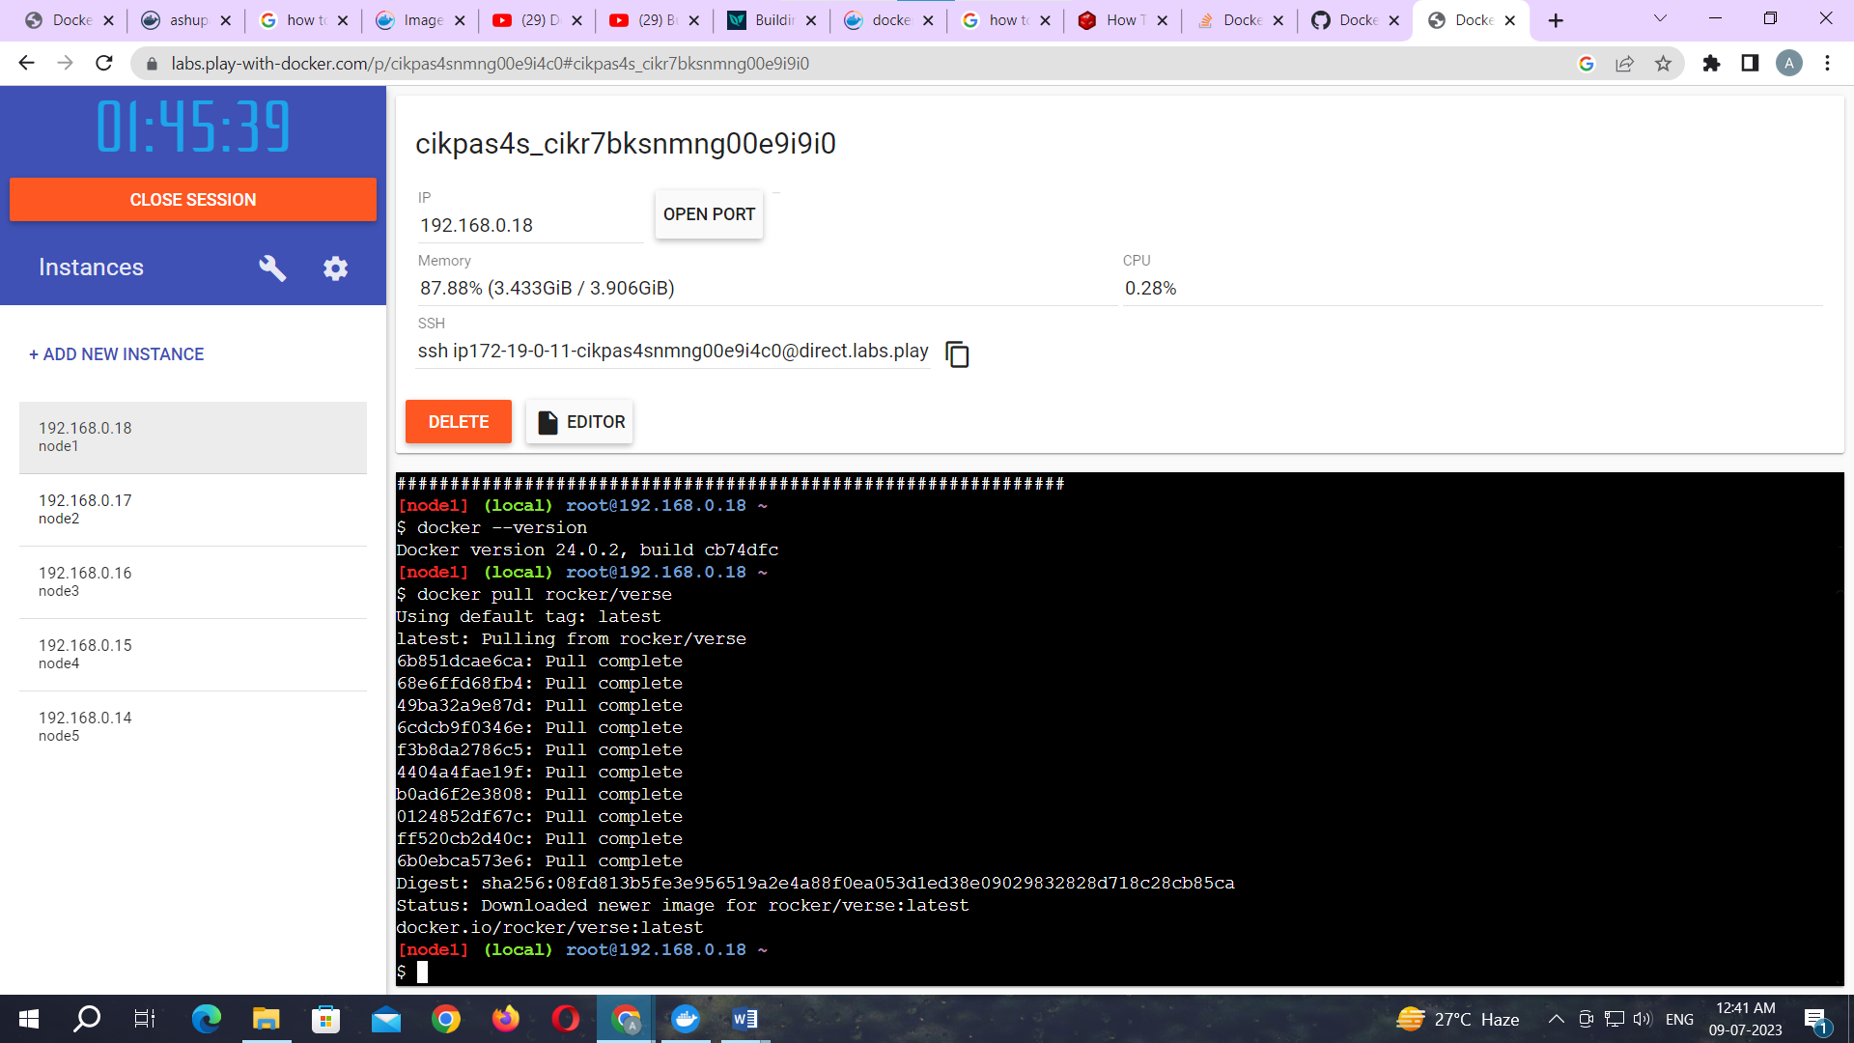

Command: to check images in docker

docker images

**Output:**

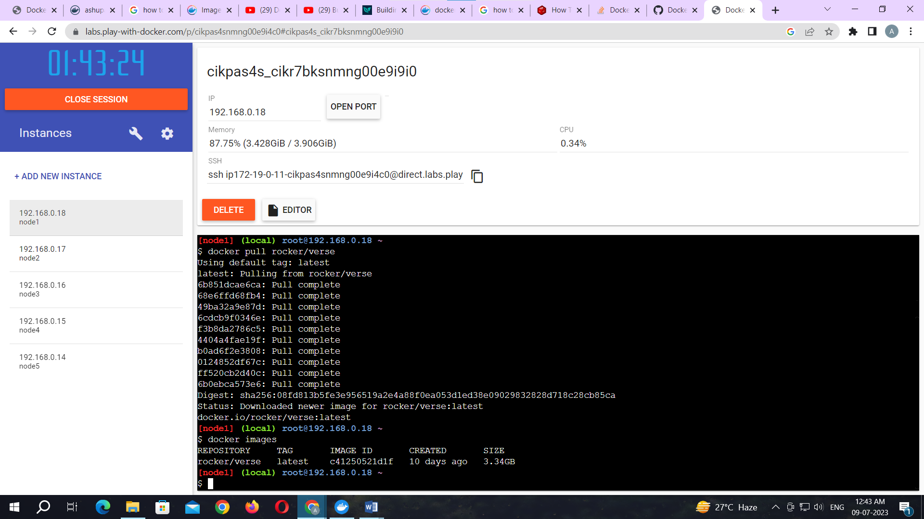

Now Login to docker hub and create repository

**Output:**

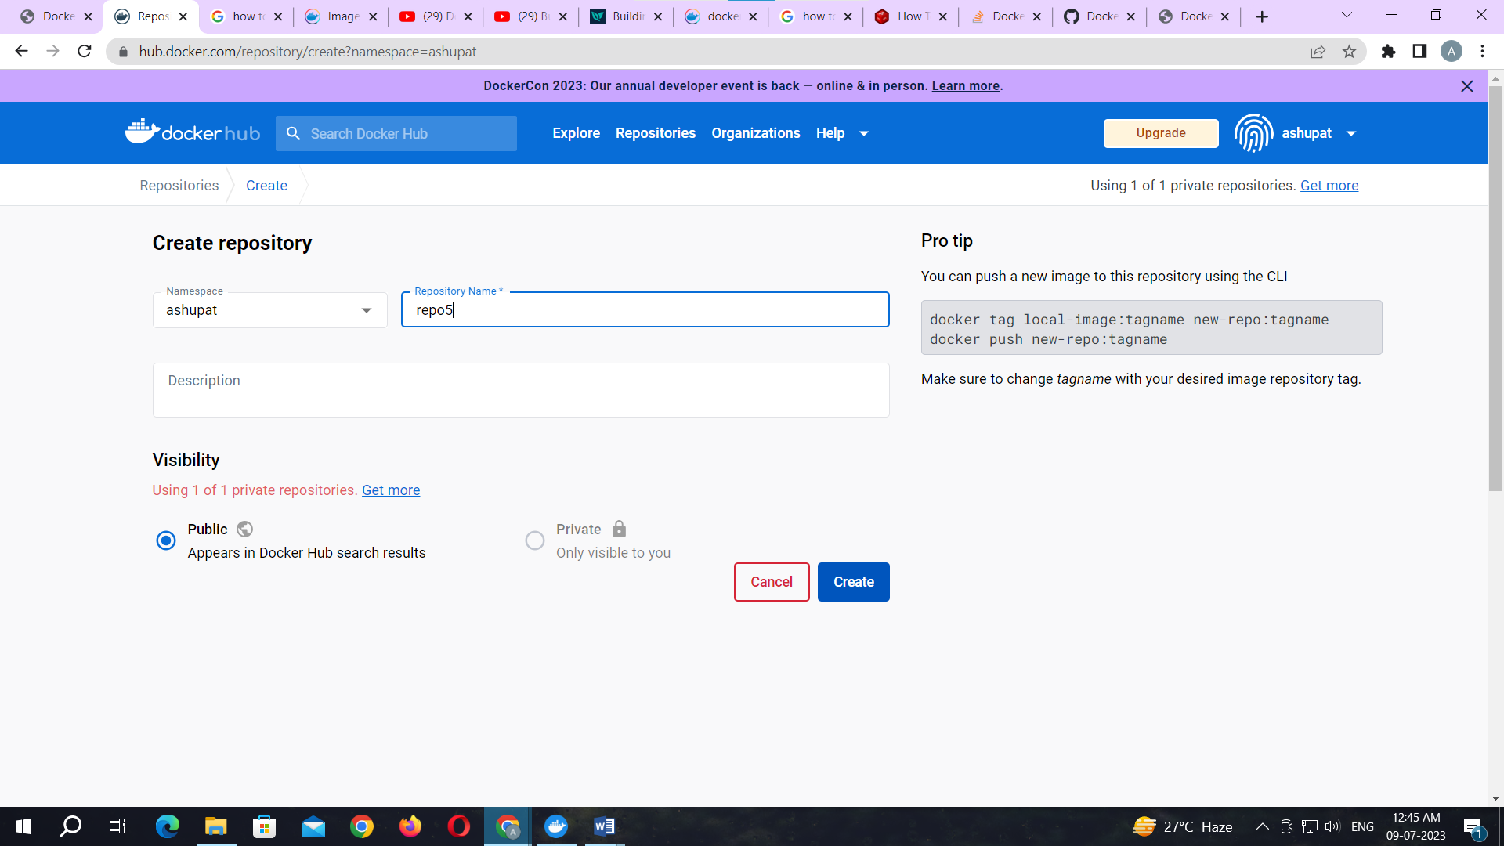

Click on Create button

Now check repository created

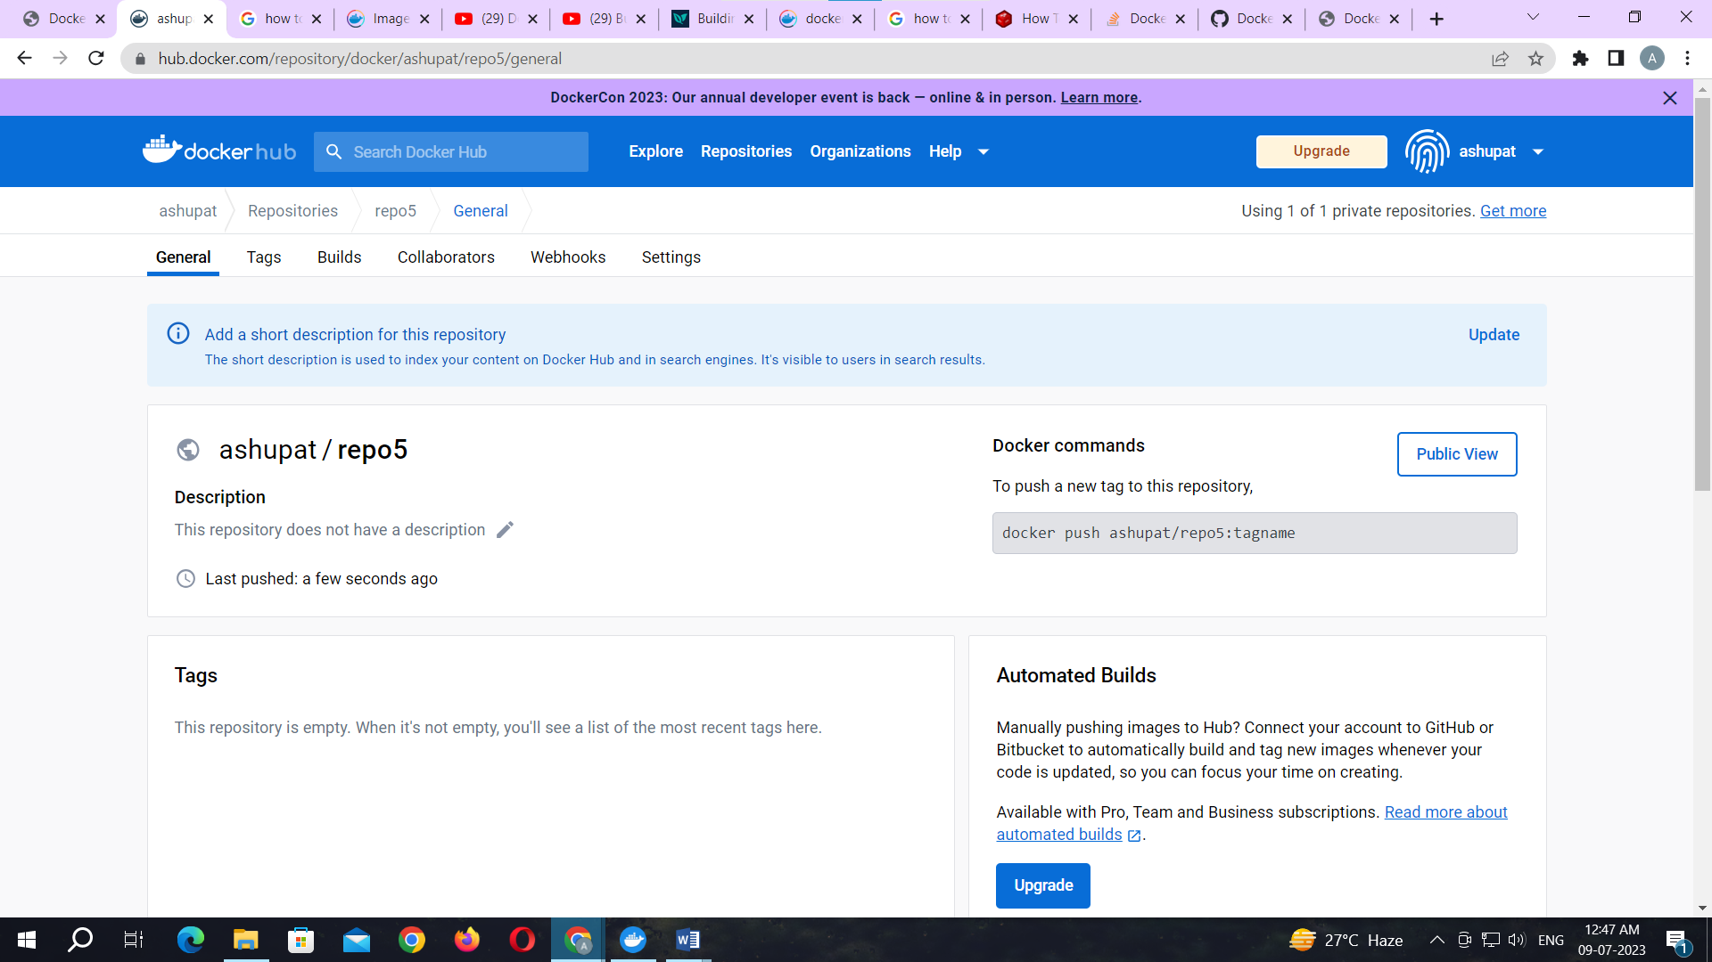

Command: to login to your docker account

docker login –username=ashupat password:

note:ashupat is my docker ID . You will use your docker ID here. And enter your password .

**Output:**

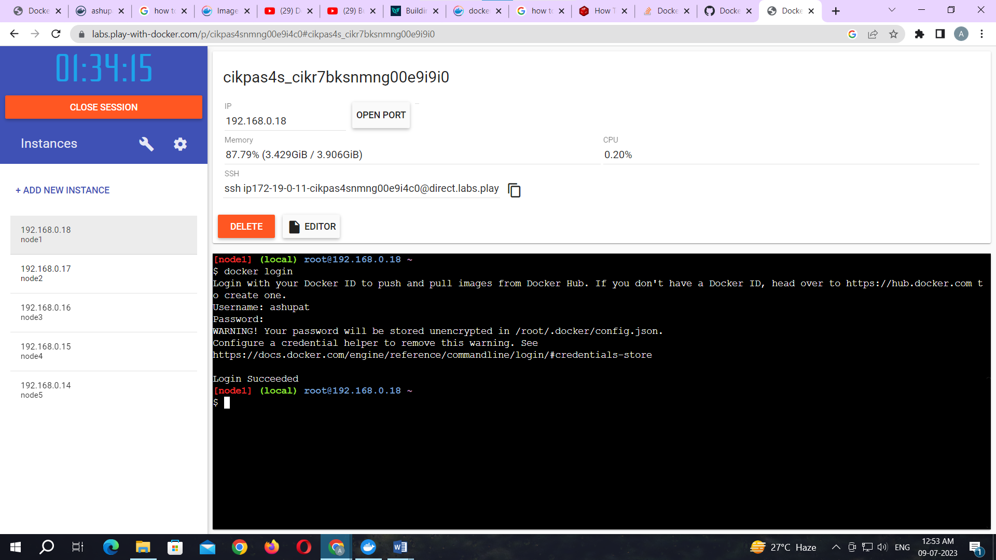

Command: to tag image

docker tag c41250521d1f ashupat/repo5:newverse

note: here c41250521d1f this is image id which you can get from docker images command.

**Output:**

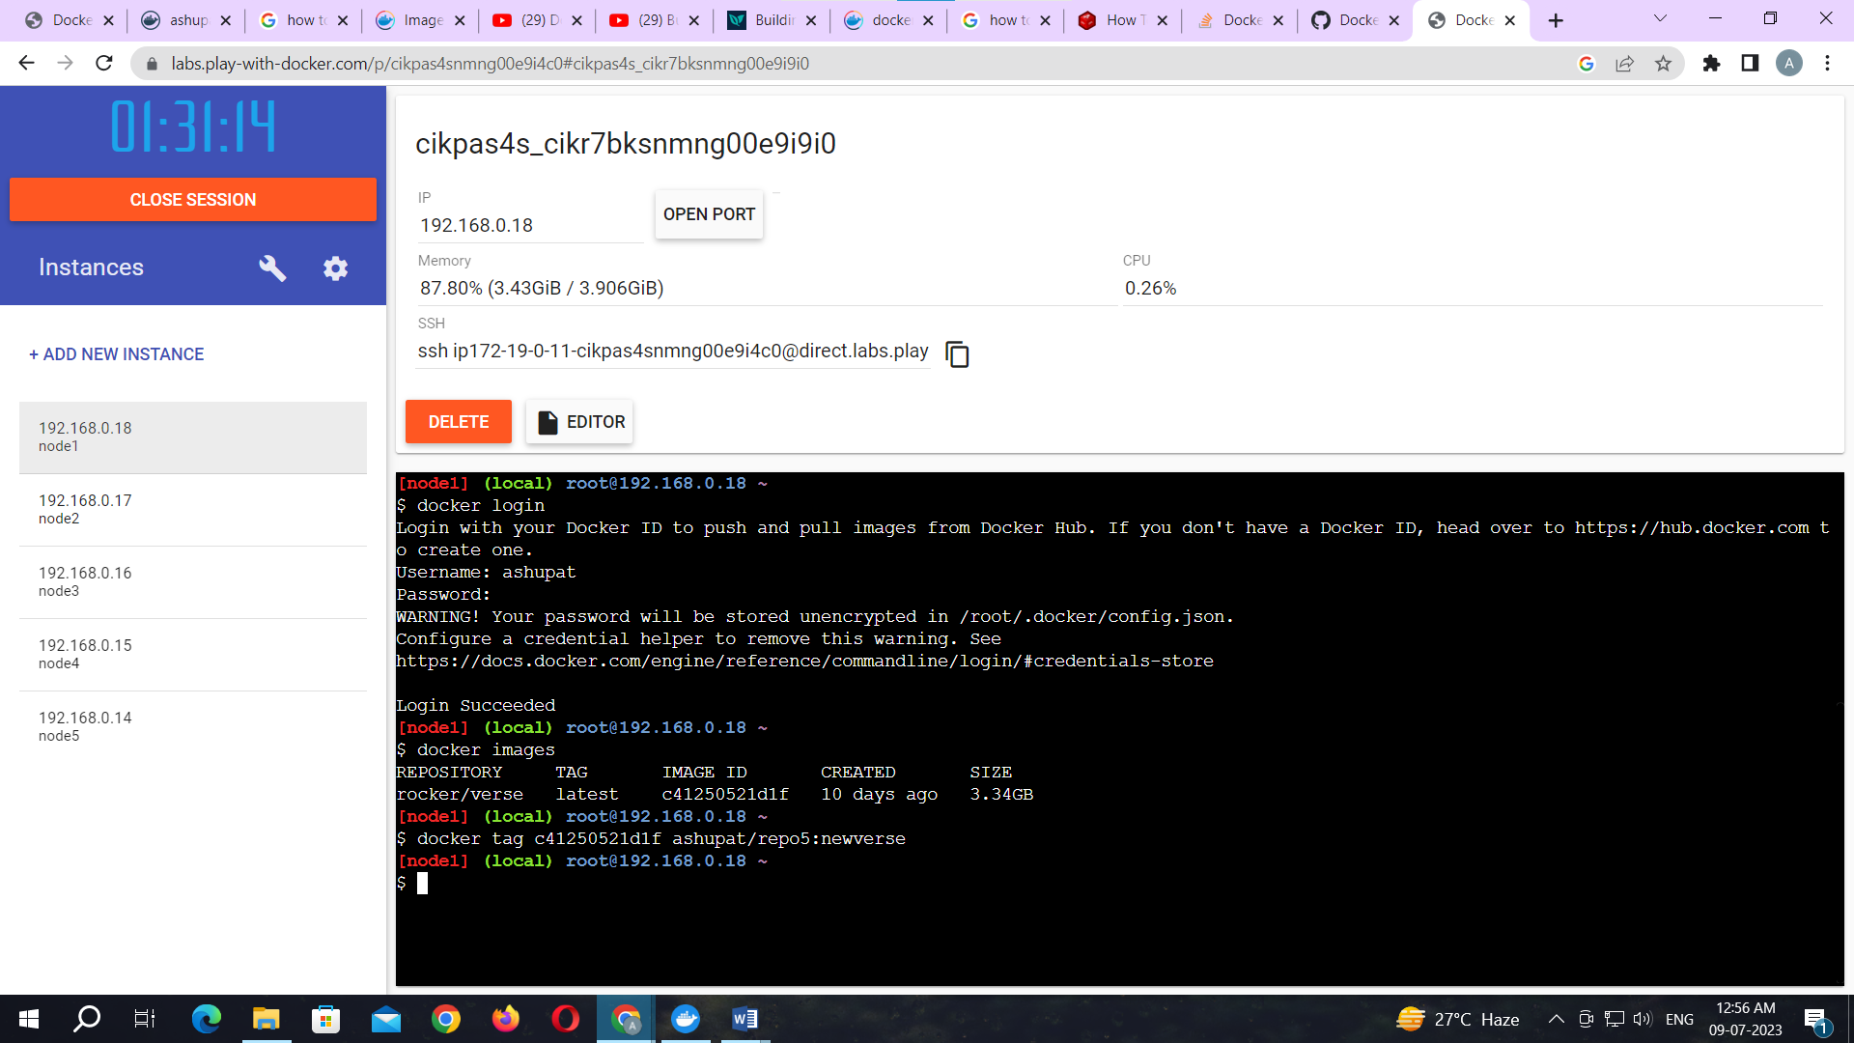

Command: to push image to docker hub account

docker push ashupat/repo5:newverse

note: newverse is tag name created above.

**Output:**

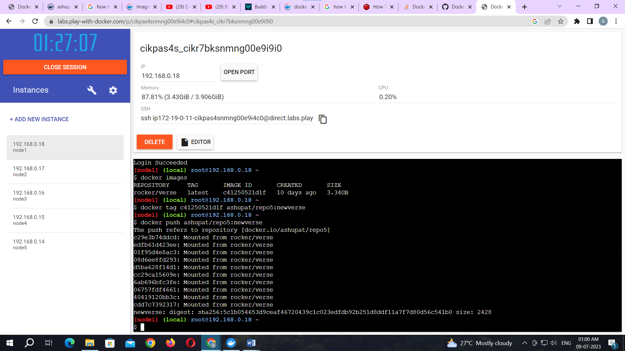

Check it in docker hub now

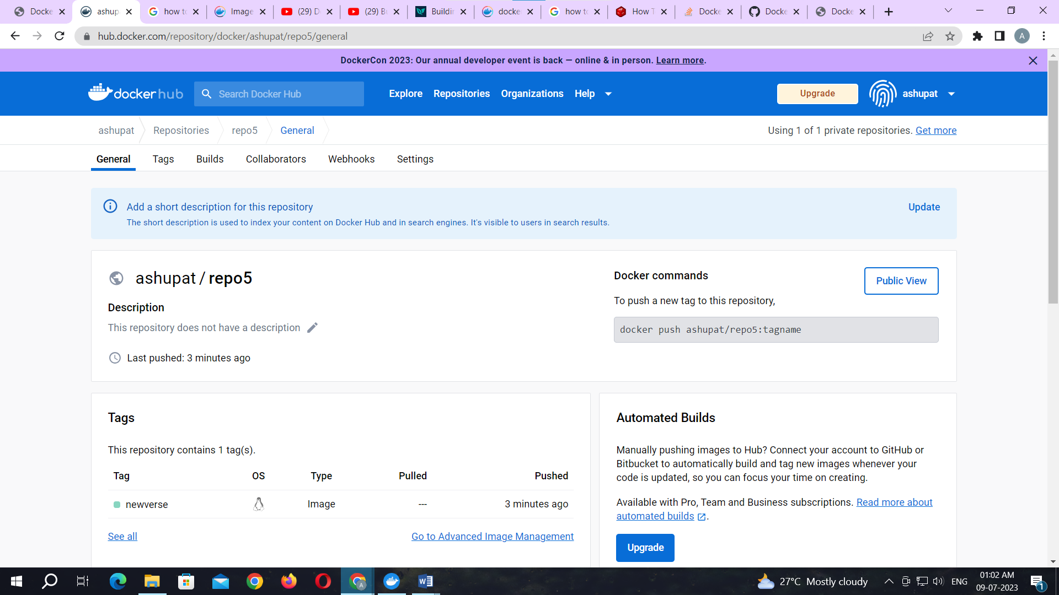

Click on tags and check.

